❖ ❖ ❖ ❖ ❖ ❖ ❖ ❖ ❖ | ✦ C O D E F E S T 2 0 2 6 ✦ | ❖ ❖ ❖ ❖ ❖ ❖ ❖ ❖ ❖

STI College San Pablo
Information Technology Department
NEXI Network | Club of Programmers
CODEFEST 2026: Local Food & Digital Commerce
Local Level Hack Day — 6-Hour Simulation

Local Competition
CODEFEST is a team competition that challenges students' skills in critical thinking, app designing, and communication as they develop and pitch innovative Android mobile applications that address a given business case. Competing teams are required to solve a business case by developing a mobile application within a certain time frame.
Competition Requirements
Each team shall:
- Develop a working application that is compliant with the specifications provided within the allotted six (6) hours;
- Only use the native Android platform (Android Studio + Kotlin/Java + Room SQLite);
- Ensure that the size of the application to be developed does NOT EXCEED 3GB; and
- Only the team captain shall be the official representative of the team.
Computing Environment
Each team will be provided with two (2) workstations. They shall use the emulators installed on each workstation to test and present their respective applications. The following are the development specifications and hardware:
Workstation Operating System | Windows 10 (64-bit)
Android Operating System | Android 7.0 (Nougat)
Integrated Development Environment | Android Studio 2.2.3 (or newer)
Programming Language | Java (JDK 21) or Kotlin
Application Display Size | 1080 x 2400 pixels

Evaluation Criteria
Functional mobile applications will be evaluated based on the following metrics:
MOBILE APPLICATION | 100 pts
Functionality  Completeness and correctness of the CRUD functions, cart quantity and total computation, checkout and order history, menu management, and role-based access logic. | 40 pts
General Appeal  Quality of the user experience, appeal to the target audience, look of the design, and excitement about the app. | 35 pts
Performance  Speed of loading and reloading times of components and their interactions. | 25 pts

❖ ❖ ❖ ❖ ❖ ❖ ❖ ❖ ❖ | ✦ C O D E F E S T 2 0 2 6 ✦ | ❖ ❖ ❖ ❖ ❖ ❖ ❖ ❖ ❖

❖ ❖ ❖ ❖ ❖ ❖ ❖ ❖ ❖ | ✦ C O D E F E S T 2 0 2 6 ✦ | ❖ ❖ ❖ ❖ ❖ ❖ ❖ ❖ ❖

Challenge Overview
In Barangay San Isidro, 'Kusina ni Aling Rosa' is the neighborhood's favorite carinderia, famous for its adobo, pancit, and halo-halo. But every lunch rush, orders arrive through text messages, shouted requests, and scribbled notes. Orders get mixed up, totals are miscomputed, and hungry customers wait in long lines while the store loses sales.
Teams must develop a mobile-based full-stack offline food ordering application that lets customers browse the menu, build a cart, and place orders from the store's counter tablet or their own phones, even without a reliable internet connection, while giving the store a simple way to manage its menu. The system must support persistent storage and implement core CRUD features but is encouraged to innovate beyond the base system.
Application Specifications (MVP)
KainTayo
"Order Your Cravings — Fast, Simple, Offline"

The team is tasked to create a full-stack Food Ordering Application, designed for offline ordering at a neighborhood eatery. Aside from the graphical user interface (GUI), the application should be able to execute the following features along with persistent data:
NOTE: These are just the base data and operations needed; feel free to add or upgrade based on your best discretion.
1. Menu Browsing & Food Details
a. View Menu List (each food shows its image, name, category, and price)
b. Filter by Category (All, Rice Meals, Noodles & Pasta, Snacks, Drinks & Desserts) & Search by Food Name
c. View Food Details
i. Image, Name, Category, Price, and Description
ii. Quantity Selector (minimum of 1; subtotal updates live as the quantity changes)
iii. Add to Cart Action
2. Cart & Checkout
a. View Cart Items (food name, unit price, quantity, and line subtotal)
b. Increase / Decrease Quantity & Remove Item (cart total updates live)
c. Adding a food that is already in the cart increases its quantity instead of creating a duplicate entry
d. Checkout
i. Customer Name
ii. Order Type (Dine-in, Take-out)
iii. Notes (optional, e.g., "no onions", "extra ice")
iv. Checkout is not allowed when the cart is empty
v. A successful checkout saves the order and empties the cart
3. Orders, Dashboard & Profile
a. Order History (newest first: order number, date, number of items, and total)
b. View Order Details (customer, order type, notes, each item with quantity and price, and order total)
c. Dashboard
i. Total Orders Placed & Total Amount Spent (₱)
ii. Most Ordered Category (by total quantity ordered)
iii. The 3 most recent orders
iv. Featured Category Pager (one card per category, using the provided banners)
d. Profile (user name, role, and order summary)
4. Menu Management (Admin Only)
a. Add Food Item
i. Food Name
ii. Category
iii. Price (PHP)
iv. Description
v. Image (one of the provided food images, or the default image)
b. Edit Food Item
c. Delete Food Item (with confirmation)
5. User Accounts & Role-Based Access
a. Log In & Sign Up (Name, Email, Password)
b. Two Roles
i. Admin — store staff who manage the menu
ii. Customer — browses the menu, orders, and views orders
c. Sign Up always creates a Customer account; the Admin account is pre-loaded (see seed data)
d. Only an Admin sees the Add Food action and the Edit / Delete controls on food items; a Customer sees the menu without them
e. Profile shows the logged-in user's name and role, with a Log Out action
f. The logged-in user stays logged in after the app is closed and reopened, until they log out
6. Innovation Layer (Developer Feature)
a. Any feature coherent to the application while providing food-ordering innovation (e.g. cart item count badge, Reorder from History, Share Order Receipt, Best-Seller tag).
b. CRUD operations are expected but not heavily required.
7. Validation & Data Integrity
a. Required fields must not be saved when empty; prices must be numeric and greater than zero, and quantities must be at least 1.
b. Invalid input must show a clear message and must never crash the application.
c. Editing or deleting a food item must not change the items or totals of orders that were already placed.
d. All dashboard figures must be computed from saved records (no hard-coded totals) and must update right after any checkout.
e. The menu, the cart, and all orders must remain after the app is closed and reopened.
f. The menu must be pre-loaded with the provided seed data on first launch and must not be duplicated on later launches.
g. A Customer must never be able to add, edit, or delete food items.
Provided Asset Pack (KainTayo_Assets/):
PROVIDED ASSET PACK — 18 IMAGES INCLUDED
Teams are provided with 12 food images, 1 default food image, 4 category banners, and 1 app logo (see KainTayo_Mock_Seed_Data.txt for file names and the full menu). Teams may also use Material Design 3 components, XML shapes/colors, Vector Drawables, and built-in Android system icons (android.R.drawable.*).
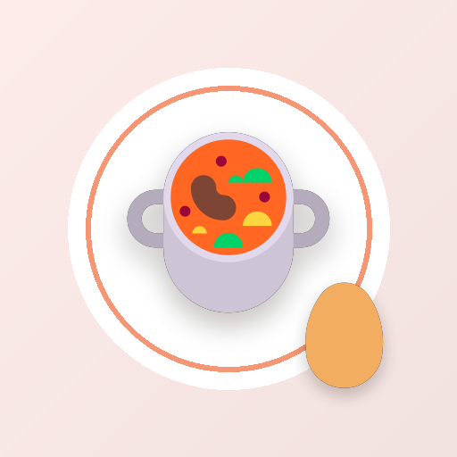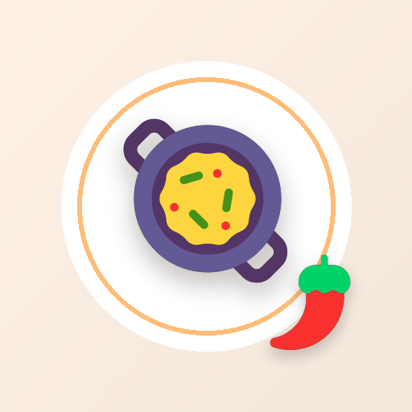
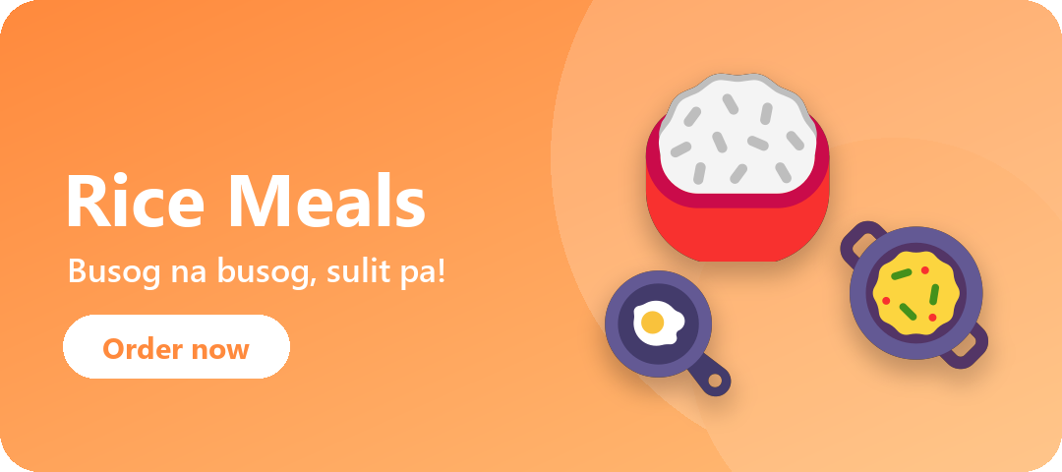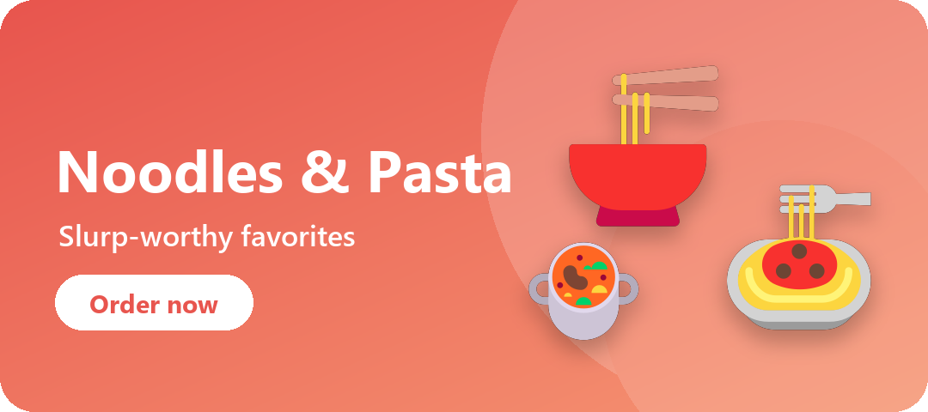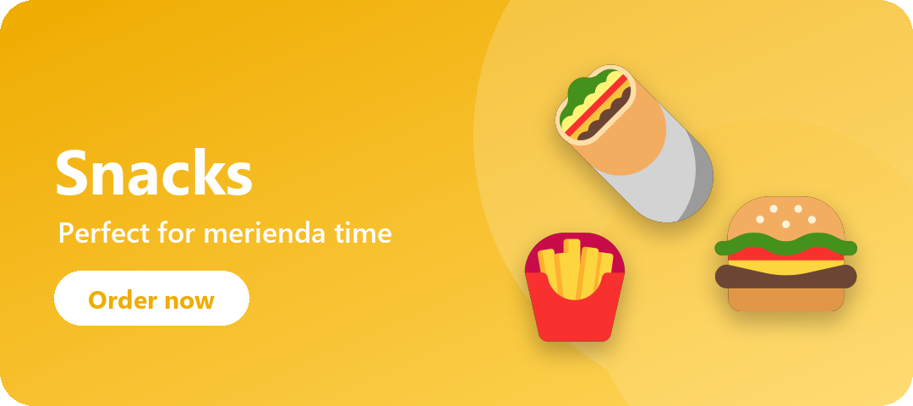

❖ ❖ ❖ ❖ ❖ ❖ ❖ ❖ ❖ | ✦ C O D E F E S T 2 0 2 6 ✦ | ❖ ❖ ❖ ❖ ❖ ❖ ❖ ❖ ❖

